// Document interface

interface Document {

void open();

}

// Concrete Document classes

class WordDocument implements Document {

public void open() {

System.out.println("Opening a Word document.");

}

}

class PdfDocument implements Document {

public void open() {

System.out.println("Opening a PDF document.");

}

}

class ExcelDocument implements Document {

public void open() {

System.out.println("Opening an Excel document.");

}

}

// Abstract Factory

abstract class DocumentFactory {

public abstract Document createDocument();

}

// Concrete Factories

class WordFactory extends DocumentFactory {

public Document createDocument() {

return new WordDocument();

}

}

class PdfFactory extends DocumentFactory {

public Document createDocument() {

return new PdfDocument();

}

}

class ExcelFactory extends DocumentFactory {

public Document createDocument() {

return new ExcelDocument();

}

}

// Main test class

public class Main {

public static void main(String[] args) {

DocumentFactory wordFactory = new WordFactory();

Document wordDoc = wordFactory.createDocument();

wordDoc.open();

DocumentFactory pdfFactory = new PdfFactory();

Document pdfDoc = pdfFactory.createDocument();

pdfDoc.open();

DocumentFactory excelFactory = new ExcelFactory();

Document excelDoc = excelFactory.createDocument();

excelDoc.open();

}

}

**USING JDoodle COMPILER**

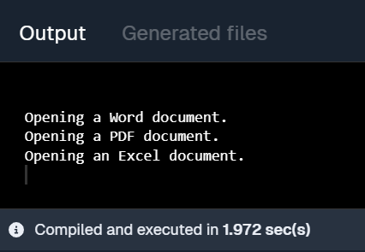

**EXERCISE 1:**

***IMPLEMENTING SINGLETON PATTERN***

class Logger {

private static Logger instance;

private Logger() {

System.out.println("Logger instance created.");

}

public static Logger getInstance() {

if (instance == null) {

instance = new Logger();

}

return instance;

}

public void log(String message) {

System.out.println("Log: " + message);

} }

public class LoggerTest {

public static void main(String[] args) {

Logger logger1 = Logger.getInstance();

logger1.log("First log message.");

Logger logger2 = Logger.getInstance();

logger2.log("Second log message.");

if (logger1 == logger2) {

System.out.println("Both logger1 and logger2 are the same instance.");

} else {

System.out.println("Different instances created! Singleton failed.");

}

}

}

**USING JDoodle COMPILER**

